# CCET 3680 Mill Lesson 1 First Exercise

I. Wireframe:

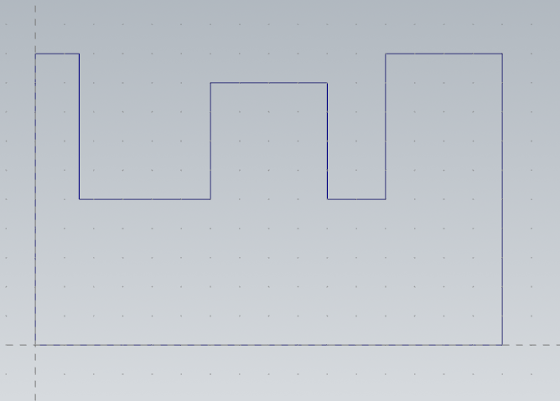

II. Dimensions:

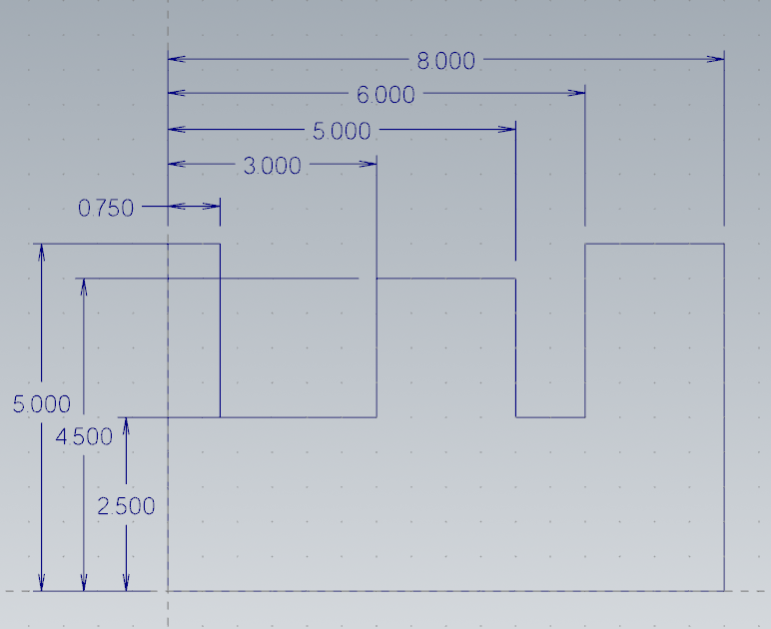

III. Solid:

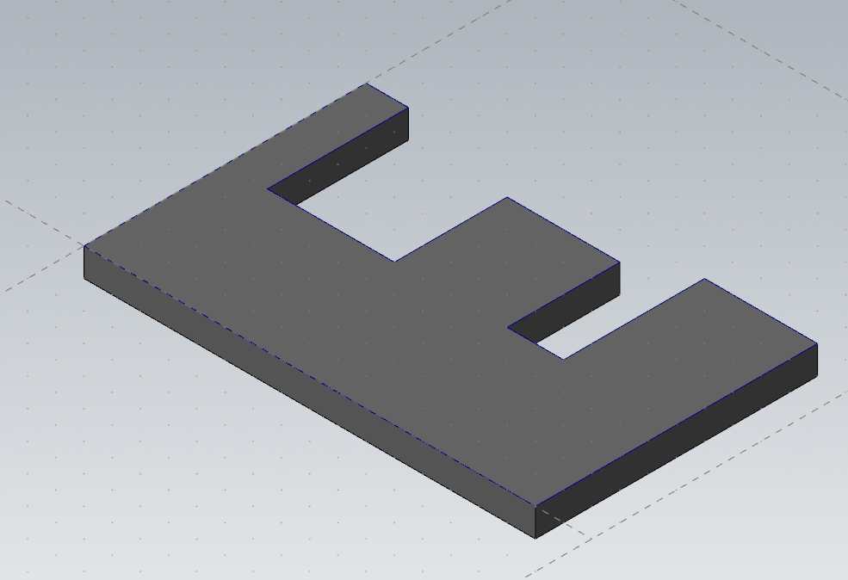

IV. Method:

I used the method shown in class of drawing a baseline that is collinear with the x axis and one that is collinear with the y axis. Then I used these lines to offset the rest of the dimensions, then used the trim and divide tools to get the final wireframe.